Debt Contagion Prediction in Cross-holding Network  
Scenario of Year 2021 and 2022

*Rebecca Li*

*Roch Jia*

*Rick Wang*

*Tiffany Zhao*

*Kathy Ding*

*Louise Shi*

Dec 14, 2022

github: <https://github.com/MustardLee/Social-Network-Analysis---Final-Project>

**I. Introduction and Background**

A debt crisis refers to a situation when a country's expenditures suppress the tax revenue amount for a prolonged period. When a debt crisis happens, banks will lose money domestically and internationally, which would cause risk to the stability and security of financial systems. Since 2019, COVID-19 has given rise to an increasing debt crisis worldwide due to financial instability and interdependency. Our research focuses on the years 2020 and 2022, which are often considered the critical time of COVID financial impact.

In this project, we intend to explore how one country's debt crisis would affect other countries and how expansive this country's influence is. In other words, if the debt crisis infects one country, how will this country defuse it to other countries? Moreover, how many countries would this country affect? How long would it take to infect a specific country? We will also measure each country's centralities and compare them to see which country is the most influential one. Finally, we give suggestions to specific countries to help them prevent or reduce potential financial contagion risks.

In our model, countries or organizations hold primitive assets and share the debts, called cross-holdings of assets between countries. Before measuring the network effects, we deploy the non-inflated GDP as the "market value" of organizations that deliver to investors outside the system. This value will show how each county's value depends on its primitive assets and any failure costs that have hit the economy. We can track how asset values and failure costs propagate through the network of interdependencies. Our results will show how the infection begins when a certain threshold is reached, resulting in "waves" or cascades of debt contagion. With the diffusion order and speed in hand, we could give suggestions to potential stakeholders, including currency investors or researchers interested in economic policies.

**II. Data Description and Exploration**

We collected total claims from the BIS Statistics Warehouse that were reported by domestic banks of each country of all maturities on an immediate counterpart basis. The data described the cross-holding debt among a group of reported countries around the world. For market value, we collect GDP and GDP forecast value from 2016 to 2022 from the International Monetary Fund's world economic outlook.

We first clean the cross-holding data with 172,000 records and over 50 countries in data.table to 2629 records, then select the columns of lend and borrow countries as to-country and from-country, and cross-holding amount in 2021-Q4 as the weight of each node to build the directed weighted graph. We use the cross-holding in 2021-Q4 because it is an excellent point to predict the 2022 debt performance, allowing us to use the most recent forecast of GDP data.

After that, we create an adjacency matrix of the graph using graph_from_data_frame in igraph. As mentioned above, our network must be fully connected to detect debt contagion between countries. Thus, we filter countries with connection pairs in both directions, leaving only 25 countries. We also normalized the nominal GDP by making the lowest GDP of each year a benchmark 1.

Further, we did an exploratory data analysis part involving the following procedures. Firstly, we made a histogram of the weight of the edges (Figure 1). As shown below, we can infer that the debt range is wide. Most countries do not have or report huge cross-holding debt, while some "outliers" may account for most of the flow in the system.

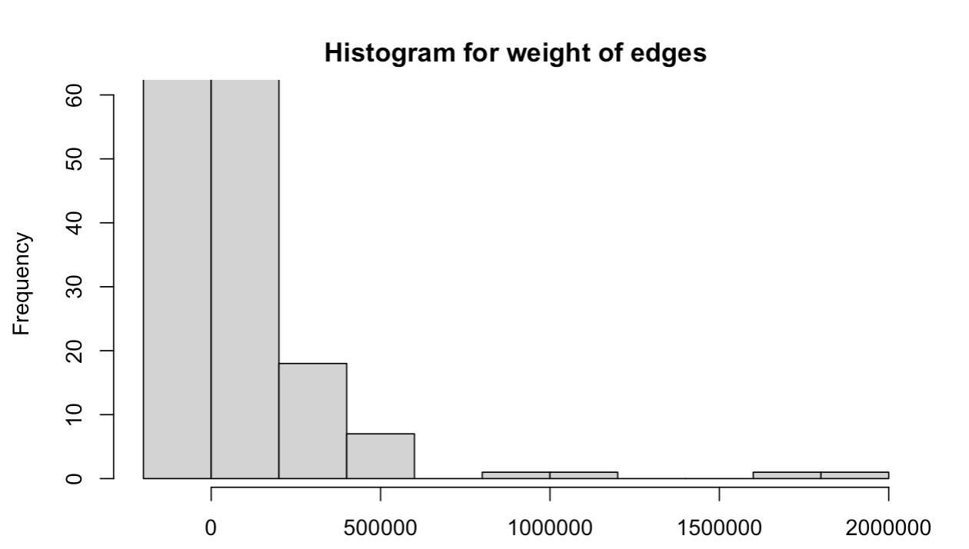

Figure 1. Histogram of Edge Weights

Secondly, to get a clear mind of the most-weighted graphs, we filtered the weights above 100 and generated a new network subset using the 2021-Q4 data. Then, we calculated the nodes' betweenness, eigenvector, and closeness centrality. The betweenness centrality measure shows that Greece is 'debt bridges' in the international debt financial system. For the EigenCentrality, we can infer that Luxembourg and Germany are the first two counties, showing their importance as a connection to the whole system. It makes sense since it evaluates their influence based on their connection with other "important" financial organizations. We also compared it with the 2020 results, in which the US and UK had the top 2 eigenvector centralities. That indicates that the two used-to-be centers need to be more connected to the world than two years ago. As for closeness centrality, EU countries have a higher connection with the world.

Table 1. Centralities of Countries

| Rank | Betweenness | EigenCentrality | Closeness |
| --- | --- | --- | --- |
| 1 | Greece | Luxembourg | France |
| 2 | Australia | Germany | United States |
| 3 | Chile | Spain | Switzerland |
| 4 | Portugal | France | United Kingdom |
| 5 | France | United Kingdom | Spain |
| 6 | Denmark | United States | Japan |
| 7 | Austria | Netherlands | Austria |
| 8 | Spain | Canada | Italy |
| 9 | Switzerland | Austria | Germany |
| 10 | Finland | Switzerland | Korea |

Thirdly, we calculate the assortativity degree of the subgraph to see whether similar points are connected. Compared to the 2020 results, the 2022 assortativity decreased from -0.20 to -0.40, indicating that the world's debt system is more divided than accumulation.

Lastly, we draft the network plot for the essential 25 counties (Figure 2), where the size of the node is its eigenvector centrality.

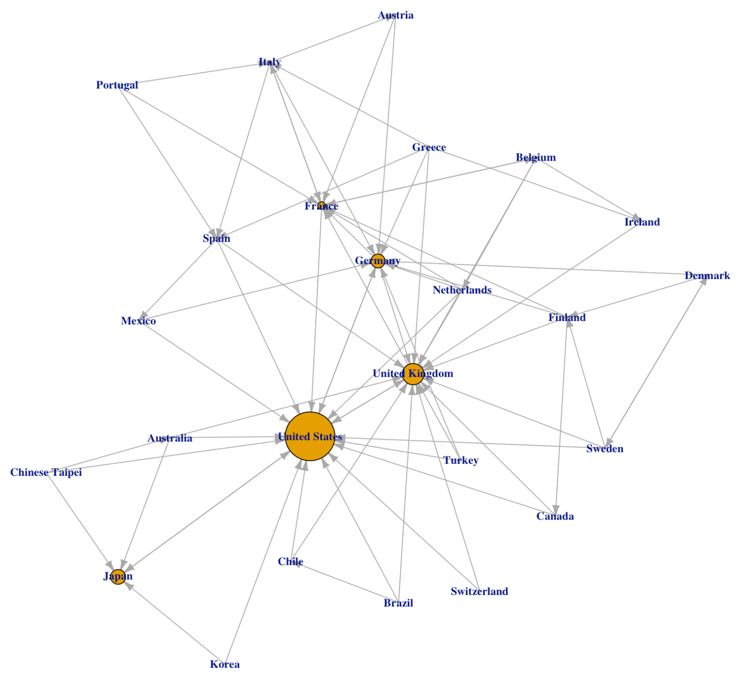

Figure 2. Simple Plot for the Network

**III. Description of Analysis Methods**

To build up our model, we assume that there are N organizations and M assets in this debt contagion system. The core relationship index for this network is defined as "interconnectivity", which is the measurement of the cross-holding of shares. The formula is shown below:

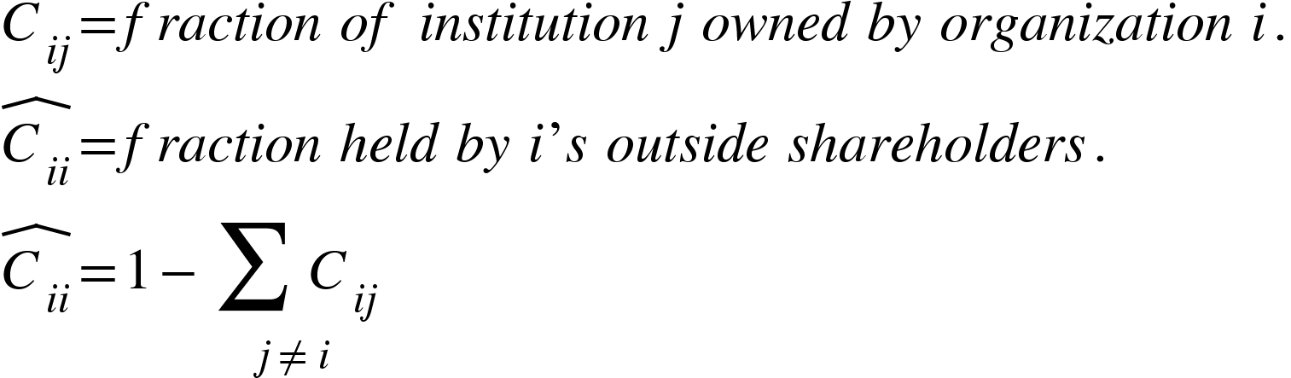

Here we estimate the ratio of total debt held outside the issuing country by 1/3.

Previous research has shown that the probability of cascades and their extent depend on two key aspects: integration and diversification. Integration refers to the level of countries' exposure to each other, and diversification refers to how spread out cross-holdings are. An economy is most susceptible to widespread cascades when 1) integration is intermediate, which means each organization has enough of its assets that idiosyncratic devaluation of those assets can cause a first failure and enough of other countries for failures to spread; 2) when countries are partly diversified, which means the network is sufficiently connected to allow cascades to spread widely, but nodes do not have so many connections that they are well-protected against the failure of any party.

For a specific country, its market value indicates the ultimate (non-inflated) value of an organization to the economy, captured by the equity value of that organization that is held by its outside investors and its primitive assets. Here, matrix A describes the dependence among countries, and p can describe its primitive assets for different assets D, represented by the 2022 (or 2020) GDP forecast of different countries.



To analyze the cascade of failures, we first need to set the threshold of failure by introducing failure cost to the equilibrium. Vector beta below describes the failure costs, the percentage of costs incurred by a debt crisis for a certain country.





After defining factors for individual countries and inter-country relationships, we decide what contagion exactly means. Generally, it is a phenomenon that a drop in the value of an asset held by j can lead to the fall in value of i even if it does not directly hold the asset. The losses are simply reallocated across the network under such situation:

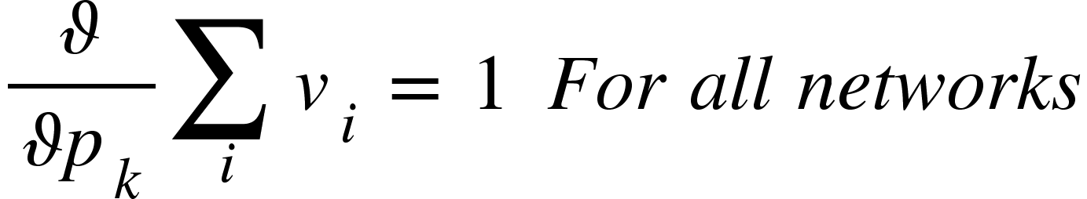

When an organization's value becomes sufficiently low, it hits a failure threshold at which it discontinuously loses additional value; this imposes losses on its counterparties, and these losses then propagate to others, even those who did not interact directly with the organization initially failing.

With the methodology translated into loops in r, we can generate the cascade results by setting different thresholds of failure (from low to high) to get the infection path and the steps. We will mainly focus on the 2022 prediction in the following analysis.

**IV. Illustration of Results**

As shown below (Table 2), with the threshold of our diffusion network changes, the contagion effect is generally more substantial and spreads faster. More specifically, with the sensitivity of failure going down, steps towards the end of the cascade go up and then down; the number of first failure countries grows step by step; the total number of failed countries grows dramatically after a certain point.

For more detailed strides, we picked the cascade with the longest failure step — 7 to dive deep into (Figure 3). The grid graph shows the relationship between countries where the threshold equals 0.96, which maximizes the step. The red area represents those countries that are infected by the debt crisis. We can tell that the infection usually goes in clusters, and brokerages can more easily infect other countries. Once the infection starts, we can observe how expansively it is spread out by observing how many countries and which countries are affected.

Also, we compare the results based on 2020 data. Instead of Brazil, Japan became the most sensitive country that caused the first failure. The threshold causing a full-network diffusion went down, which means that the graph is more susceptible than 2020. However, key brokerage countries, including Italy and France, do not change much, and they still play as the trigger to a full debt contiguous breakdown.

Table 2. Wave of Cascade in Different Threshold

| Theta | Total_Wave | First_Fail_Num | All_Fail_Num |
| --- | --- | --- | --- |
| 0.94 | 1 | 1 | 1 |
| 0.95 | 3 | 2 | 6 |
| 0.96 | 7 | 2 | 16 |
| 0.97 | 4 | 3 | 16 |
| 0.98 | 4 | 4 | 16 |
| 0.99 | 3 | 6 | 16 |
| 1 | 3 | 7 | 16 |
| 1.01 | 2 | 10 | 16 |
| 1.02 | 4 | 11 | 21 |
| 1.03 | 3 | 12 | 22 |
| 1.04 | 3 | 16 | 23 |
| 1.05 | 3 | 19 | 24 |

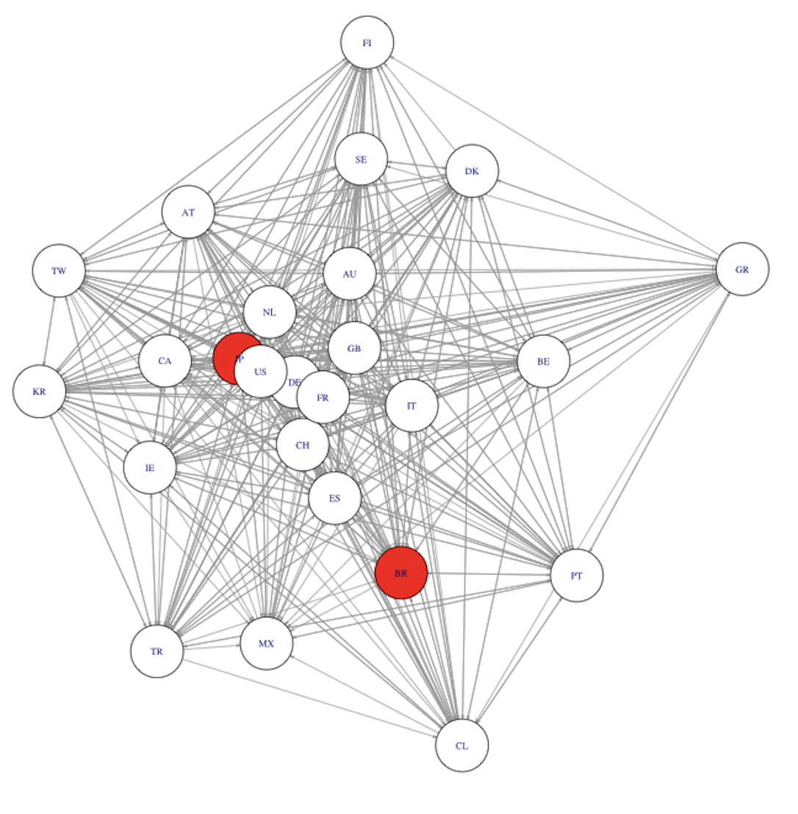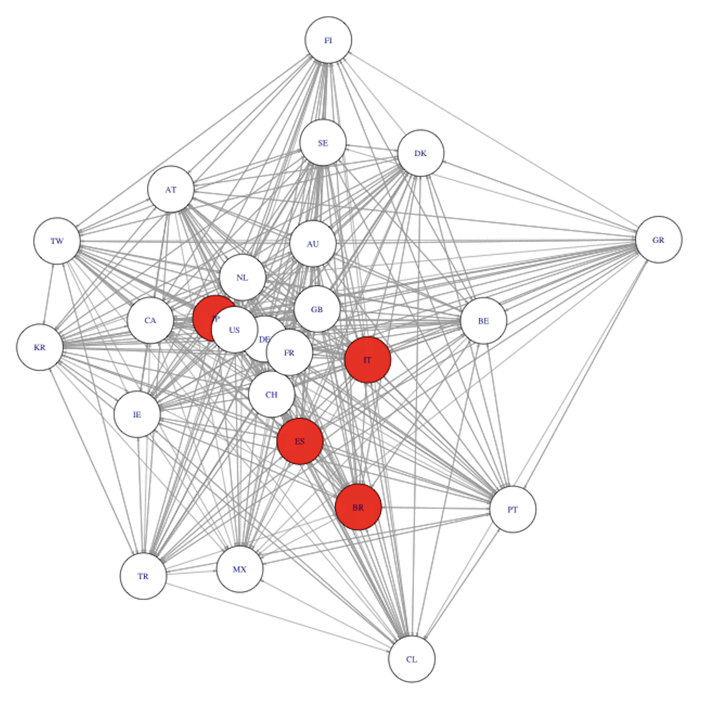

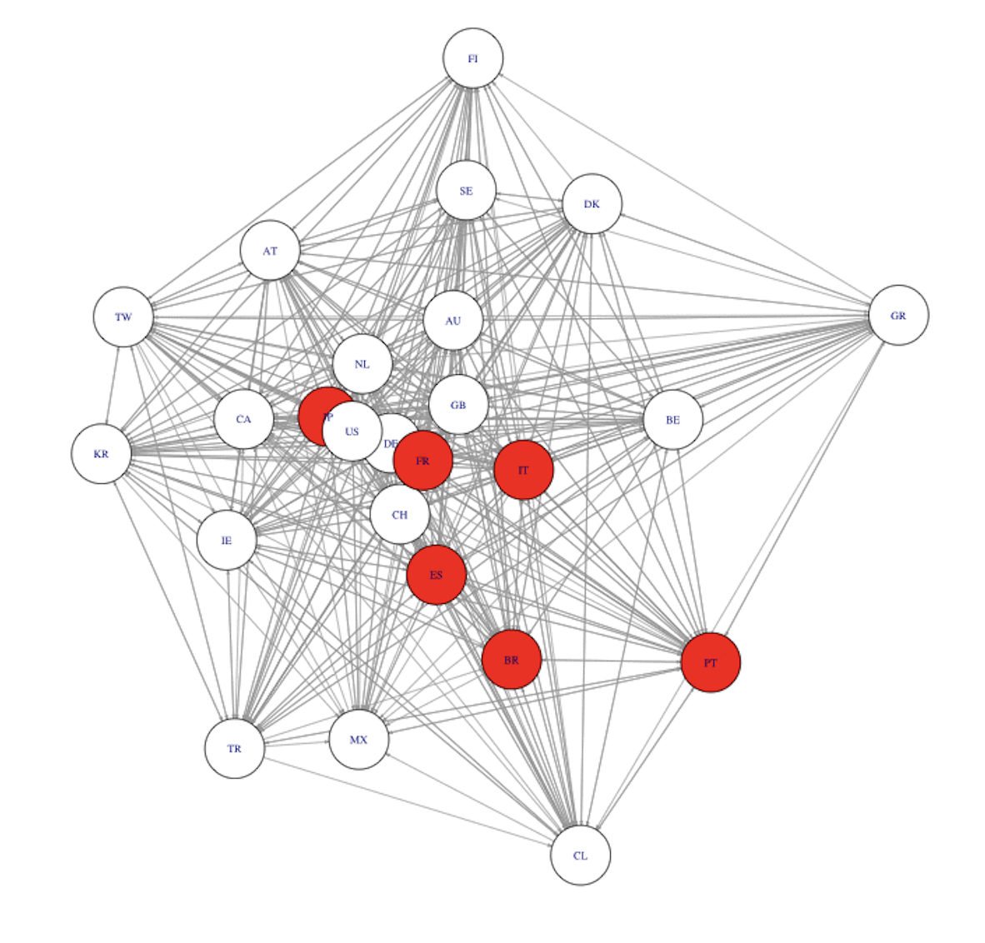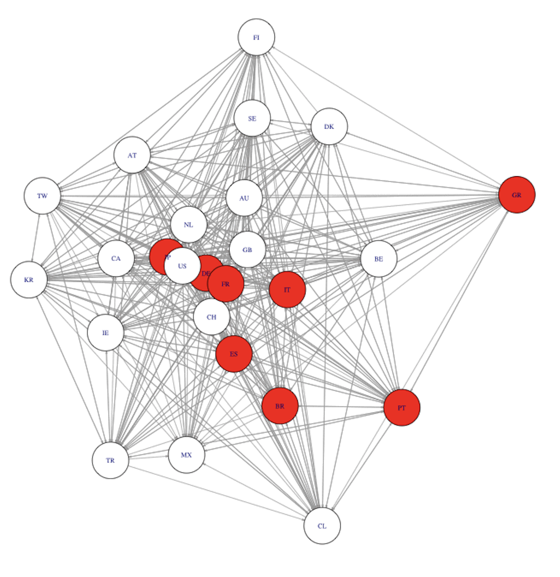

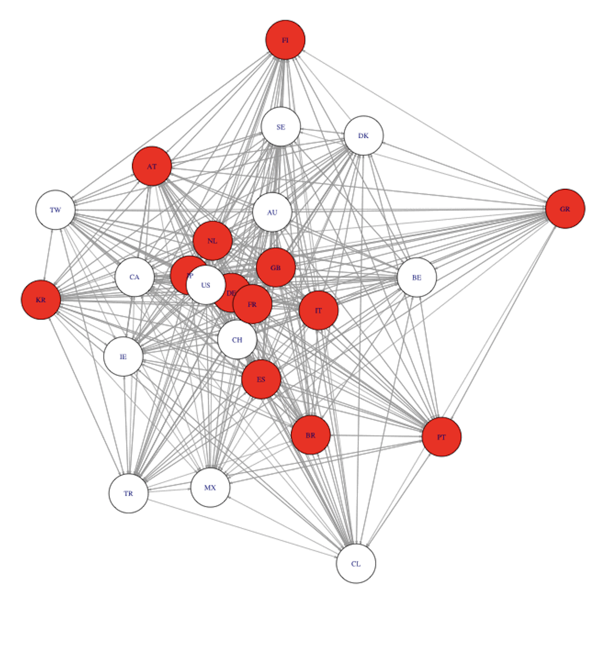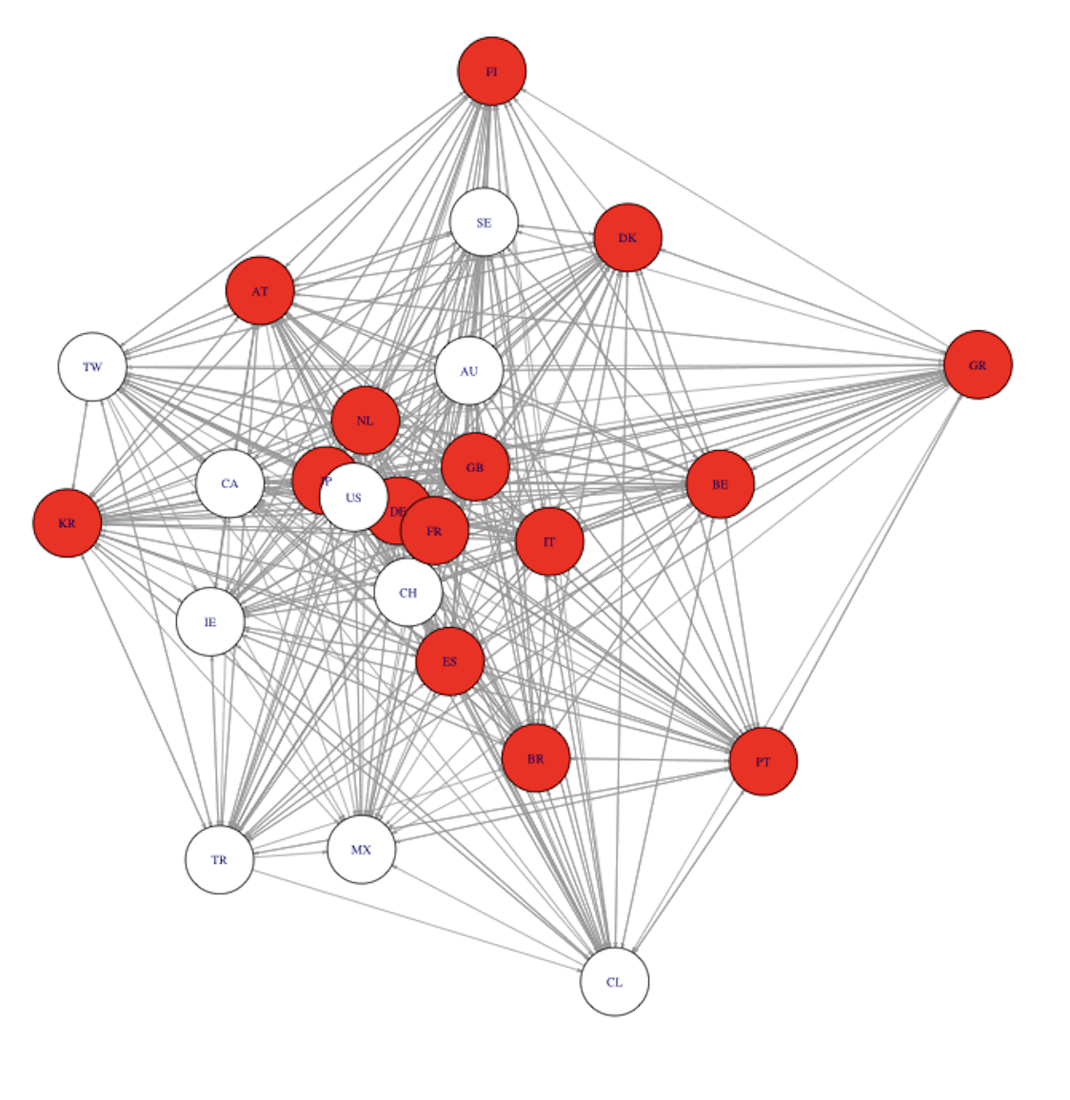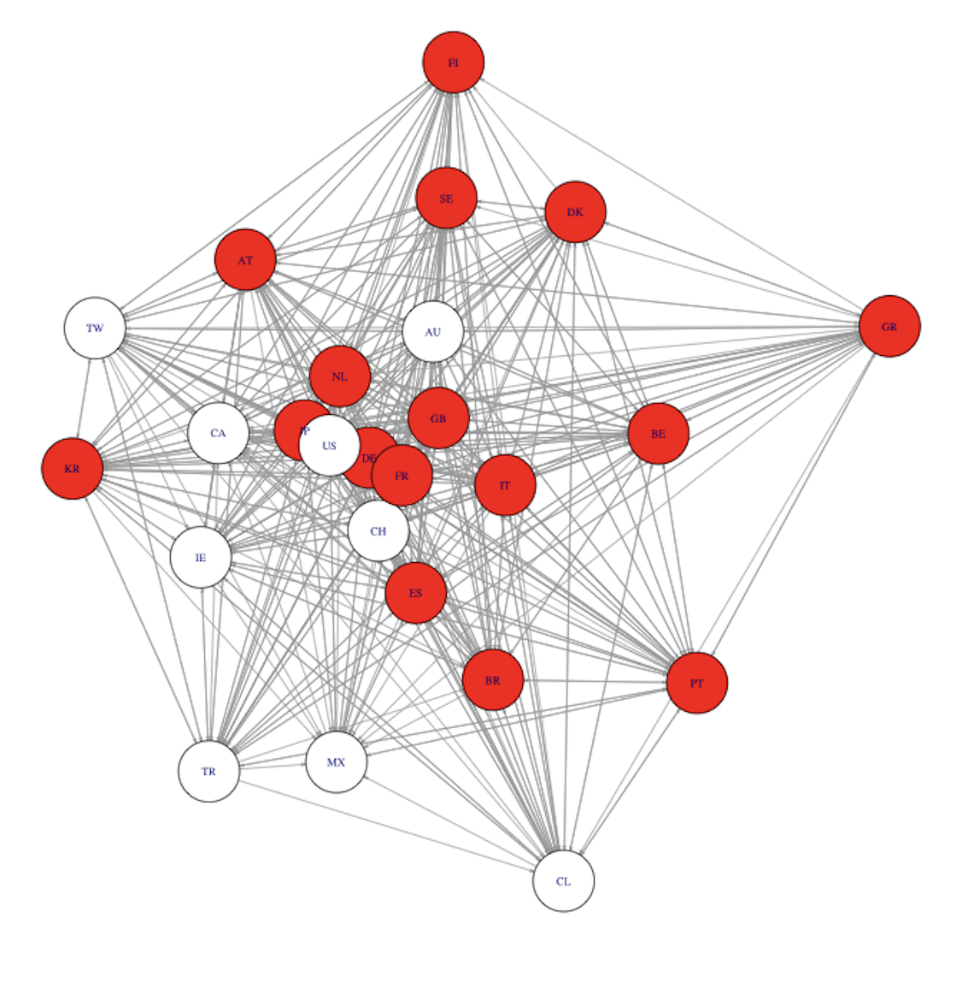

Figure 3. Cascade Step with Longest Stride

We could summarize the pattern in three steps:

1. A first failure: some organization is susceptible enough to shocks in some assets.
2. Contagion: some other organizations are sufficiently sensitive to the first organization's failure that they also fail.
3. Interconnection: the network of cross-holdings is sufficiently connected so that the failures can continue to propagate and are not limited to some small component.

Although these might occur all at once in practice, it can be helpful to distinguish the sequence of dependencies to figure out how they might be avoided. Some initial failures are enough to cause a second wave of countries to fail. Once these countries fail, the third wave of failures may occur, and so on.

**V. Conclusions and Implications**

In conclusion, we studied the global debt network during the 2020-2022 period and analyzed the interconnectivity and the contagion effect. Two major findings are: first, the debt infection goes into diffusion. Therefore, brokerage countries with high primitive value tend to infect other entities more easily. It is held that the European Debt Crisis was initiated by Greece defaulting on its debt and spread out when Italy and Spain were also infected (Mink, 2013).

Second, the debt contagion network has changed from 2020 to 2022, so the latest network takes fewer steps to infect the whole network. This pattern agrees with Matesanza and Ortega's research on European sovereign public debt, which indicates that countries' public debt synchronizes over time, "increasing global connectivity in the network and dramatically decreasing the number of communities" (Matesanz, Ortega, 2015). Since the outburst of Covid-19, developing countries have faced more severe public health and economic challenges, causing them to increase their national indebtedness. Several countries, such as Argentina, Ecuador, Ethiopia, and Lebanon, defaulted on debt (Arellano, 2020). Those countries may not guarantee a cascade of failure because of their primitive asset value; however, we should keep an eye on the essential countries that are easy to fail (Japan & Brazil) and those that play as the brokerages (Italy & Spain & France). Apart from those, we could also have a peak on the more “diving” financial system, including the effect of Brexit and the Russia-Ukraine war if given the full graph of the world.

Given that the global debt network is a highly connected entity, it emphasizes the significance of collective efforts in preventing the default on the national debt and a worldwide financial crisis. International organizations, including IMF, World Bank, and the InterAmerican Development Bank, have enacted programs for debt relief, for example, by extending the repayment and waiving debt service fees. Helping the heavily indebted countries, which are usually high in betweenness centrality, would prevent the spread of default to many other linked countries and benefit the global economic network.

**Reference**

Arellano, Cristina, et al. “Deadly Debt Crises: Covid-19 in Emerging Markets.” 2020, https://doi.org/10.3386/w27275.

Mink, Mark, and Jakob De Haan. “Contagion during the Greek Sovereign Debt Crisis.” *Journal of International Money and Finance*, vol. 34, 2013, pp. 102–113., https://doi.org/10.1016/j.jimonfin.2012.11.006.

Matesanz, David, and Guillermo J. Ortega. “Sovereign Public Debt Crisis in Europe. A Network Analysis.” *Physica A: Statistical Mechanics and Its Applications*, vol. 436, 2015, pp. 756–766., https://doi.org/10.1016/j.physa.2015.05.052.